

**BIM PROJECT EXECUTION PLAN**

*FOR*

**IZMIR INTEGRATED HEALTH CAMPUS PROJECT**

**INTENSIVE CARE UNITS (ICU) BIM EXECUTION PLAN**

*DEVELOPED BY*

**GROUP İZMİR ÜÇLÜSÜ (IZU)**

TABLE OF CONTENTS

**SECTION A: BIM PROJECT EXECUTION PLAN OVERVIEW** 2

**SECTION B: PROJECT INFORMATION** 3

**SECTION C: KEY PROJECT CONTACTS** 5

**SECTION D: PROJECT GOALS / BIM USES** 6

**SECTION E: ORGANIZATIONAL ROLES / STAFFING** 7

**SECTION F: BIM PROCESS DESIGN** 8

**SECTION G: BIM INFORMATION EXCHANGES** 9

**SECTION H: BIM AND FACILITY DATA REQUIREMENTS** 10

**SECTION I: COLLABORATION PROCEDURES** 11

**SECTION J: QUALITY CONTROL** 13

**SECTION K: TECHNOLOGICAL INFRASTRUCTURE NEEDS** 14

**SECTION L: MODEL STRUCTURE** 15

**SECTION M: PROJECT DELIVERABLES** 16

**SECTION N: DELIVERY STRATEGY / CONTRACT** 17

**SECTION O: ATTACHMENTS** 18

# **SECTION A: BIM PROJECT EXECUTION PLAN OVERVIEW**

To successfully implement Building Information Modeling (BIM) on a project, the project team has developed this detailed BIM Project Execution Plan. The BIM Project Execution Plan defines uses for BIM on the project (e.g. design authoring, cost estimating, and design coordination), along with a detailed design of the process for executing BIM throughout the project lifecycle.

# **SECTION B: PROJECT INFORMATION**

1. **PROJECT OWNER**

*İstanbul Teknik Üniversitesi IYB501 Dersi Sorumluları*

1. **PROJECT NAME**

*IZMIR INTEGRATED HEALTH CAMPUS PROJECT*

*INTENSIVE CARE UNITS (ICU)*

1. **PROJECT LOCATION AND ADDRESS:**

*İzmir Bayraklı Entegre Sağlık Kampüsü, Refik Şevket İnce Mahallesi 2148/11 Sokak, No:1/11 Bayraklı İZMİR*

1. **CONTRACT TYPE / DELIVERY METHOD:**

*Public Private Partnership, Build Operate Transfer Delivery Method*

1. **BRIEF PROJECT DESCRIPTION:**

*'- Total Construction Area: (Y12-Y18 – X39-X44) 1920 m² in 631,320 m²*

*- In Main Hospital facility, MT2&3 block Floor 4th – 5th*

* *Bed Capacity: 18*
* *Intensive Care Units: 18*
* *Asepsis Room: 6*

1. **ADDITIONAL PROJECT INFORMATION:**

*Developing and coordinating the static, architectural and HVAC BIM models of the area between X39-X44 - Y12-Y18 axes on the 4th and 5th floors where the Intensive Care Units are located in the MT2&3 block of the Main Hospital building.*

1. **PROJECT NUMBERS:**

|  |  |
| --- | --- |
| **PROJECT INFORMATION** | **NUMBER** |
| CONTRACT NUMBER | 1 |
| TASK ORDER | 1 |
| PROJECT NUMBER | 1 |

1. **PROJECT SCHEDULE / PHASES / MILESTONES:**

|  |  |  |  |
| --- | --- | --- | --- |
| **PROJECT PHASE / MILESTONE** | **ESTIMATED START DATE** | **ESTIMATED COMPLETION DATE** | **PROJECT STAKEHOLDERS INVOLVED** |
| PRELIMINARY PLANNING | 26.10.2022 | 02.11.2022 |  |
| DESIGN DOCUMENTS | 01.11.2022 | 12.11.2022 |  |
| CLASHING DETECTION | 12.11.2022 | 20.11.2022 |  |
| DESIGN REVIEW | 21.11.2022 | 05.12.2022 | 07.12.2022 |

# **SECTION C: KEY PROJECT CONTACTS**

|  |  |  |  |  |  |
| --- | --- | --- | --- | --- | --- |
| **ROLE** | **ORGANIZATION** | **CONTACT NAME** | **LOCATION** | **E-MAIL** | **PHONE** |
| Project Manager(s) | İzmir Üçlüsü | M. Selim Soysal | İzmir | [SOYSAL22@ITU.EDU.TR](mailto:SOYSAL22@ITU.EDU.TR) | +905555153180 |
| BIM Manager(s) | İzmir Üçlüsü | Ali Erişir | İstanbul | [ERISIR22@ITU.EDU.TR](mailto:ERISIR22@ITU.EDU.TR) | +905078773866 |
| Discipline Leads | İzmir Üçlüsü | Eray Uzun | İzmir | [UZUNE22@ITU.EDU.TR](mailto:UZUNE22@ITU.EDU.TR) | +905557695797 |
| Other Project Roles | İzmir Üçlüsü | Uğurcan Çakal | İzmir | [CAKAL22@ITU.EDU.TR](mailto:CAKAL22@ITU.EDU.TR) | +905303009556 |

# **SECTION D: PROJECT GOALS / BIM USES**

1. **MAJOR BIM GOALS / OBJECTIVE:**

|  |  |  |
| --- | --- | --- |
| **PRIORITY** | **GOAL DESCRIPTION** | **POTENTIAL BIM USES** |
|  | Determining the scope of the project, preparing the work plan and assigning tasks. | PROGRAMMING |
|  | Creation of BIM models | DESIGN AUTHORING |
|  | Clash detection | 3D COORDINATION |
|  | Scheduling and budgeting studies with the quantities obtained from the BIM model, creating a 4D model. | PHASE PLANNING  (4D MODELING) and COST ESTIMATION |

1. **BIM USE ANALYSIS WORKSHEET: ATTACHMENT 1**
2. **BIM USES:**

|  |  |  |  |  |  |  |  |
| --- | --- | --- | --- | --- | --- | --- | --- |
| **X** | **PLAN** | **X** | **DESIGN** | **X** | **CONSTRUCT** | **X** | **OPERATE** |
| X | PROGRAMMING | X | DESIGN AUTHORING |  | SITE UTILIZATION PLANNING |  | BUILDING MAINTENANCE SCHEDULING |
|  | SITE ANALYSIS | X | DESIGN REVIEWS |  | CONSTRUCTION SYSTEM DESIGN |  | BUILDING SYSTEM ANALYSIS |
|  |  | X | 3D COORDINATION |  | 3D COORDINATION |  | ASSET MANAGEMENT |
|  |  |  | STRUCTURAL ANALYSIS |  | DIGITAL FABRICATION |  | SPACE MANAGEMENT / TRACKING |
|  |  |  | LIGHTING ANALYSIS |  | 3D CONTROL AND PLANNING |  | DISASTER PLANNING |
|  |  |  | ENERGY ANALYSIS |  | RECORD MODELING |  | RECORD MODELING |
|  |  |  | MECHANICAL ANALYSIS |  |  |  |  |
|  |  |  | OTHER ENG. ANALYSIS |  |  |  |  |
|  |  |  | SUSTAINABLITY (LEED) EVALUATION |  |  |  |  |
|  |  |  | CODE VALIDATION |  |  |  |  |
|  | PHASE PLANNING  (4D MODELING) | X | PHASE PLANNING  (4D MODELING) |  | PHASE PLANNING  (4D MODELING) |  | PHASE PLANNING  (4D MODELING) |
|  | COST ESTIMATION | X | COST ESTIMATION |  | COST ESTIMATION |  | COST ESTIMATION |
|  | EXISTING CONDITIONS MODELING |  | EXISTING CONDITIONS MODELING |  | EXISTING CONDITIONS MODELING |  | EXISTING CONDITIONS MODELING |

# **SECTION E: ORGANIZATIONAL ROLES / STAFFING**

1. **BIM ROLES AND RESPONSIBILITIES:**
2. **BIM USE STAFFING:**

|  |  |  |  |  |  |
| --- | --- | --- | --- | --- | --- |
| **BIM USE** | **ORGANIZATION** | **NUMBER OF TOTAL STAFF FOR BIM USE** | **ESTIMATED WORKER HOURS** | **LOCATION(S)** | **LEAD CONTACT** |
|  |  |  |  |  |  |
|  |  |  |  |  |  |
|  |  |  |  |  |  |
|  |  |  |  |  |  |

# **SECTION F: BIM PROCESS DESIGN**

1. **LEVEL ONE PROCESS OVERVIEW MAP: ATTACHMENT 2**

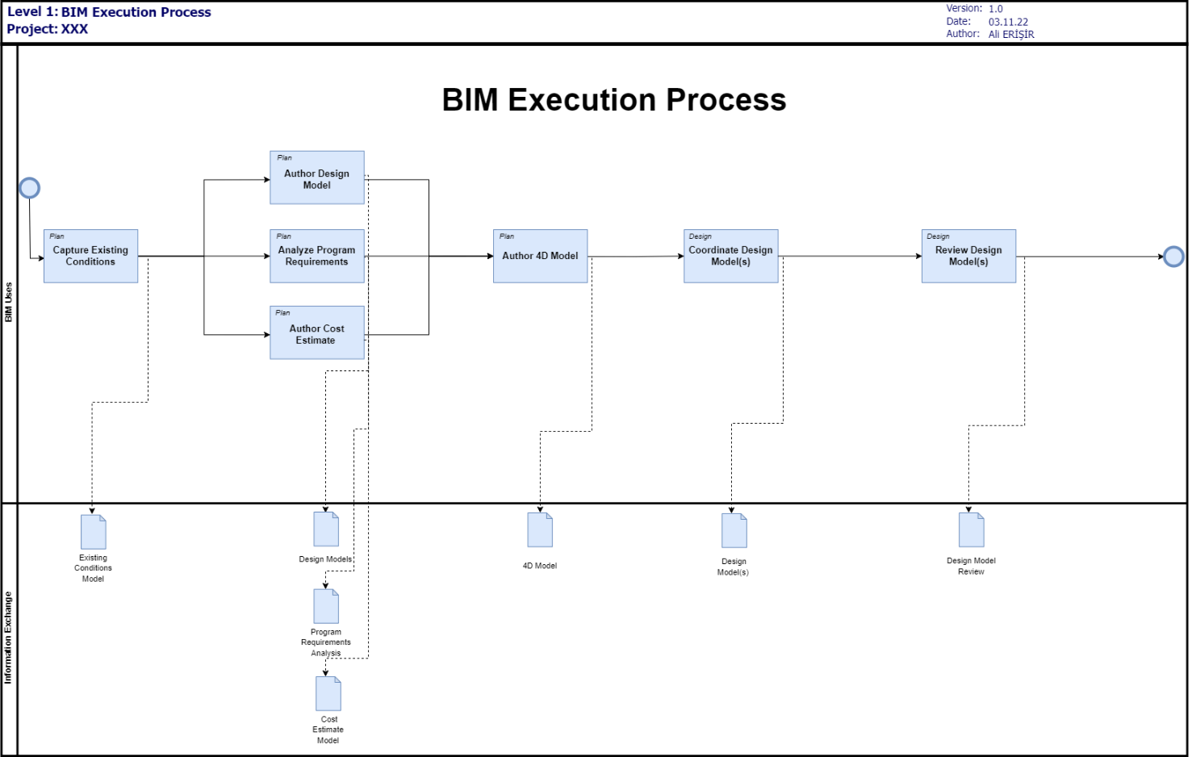

1. **LIST OF LEVEL TWO – DETAILED BIM USE PROCESS MAP(S): ATTACHMENT 3**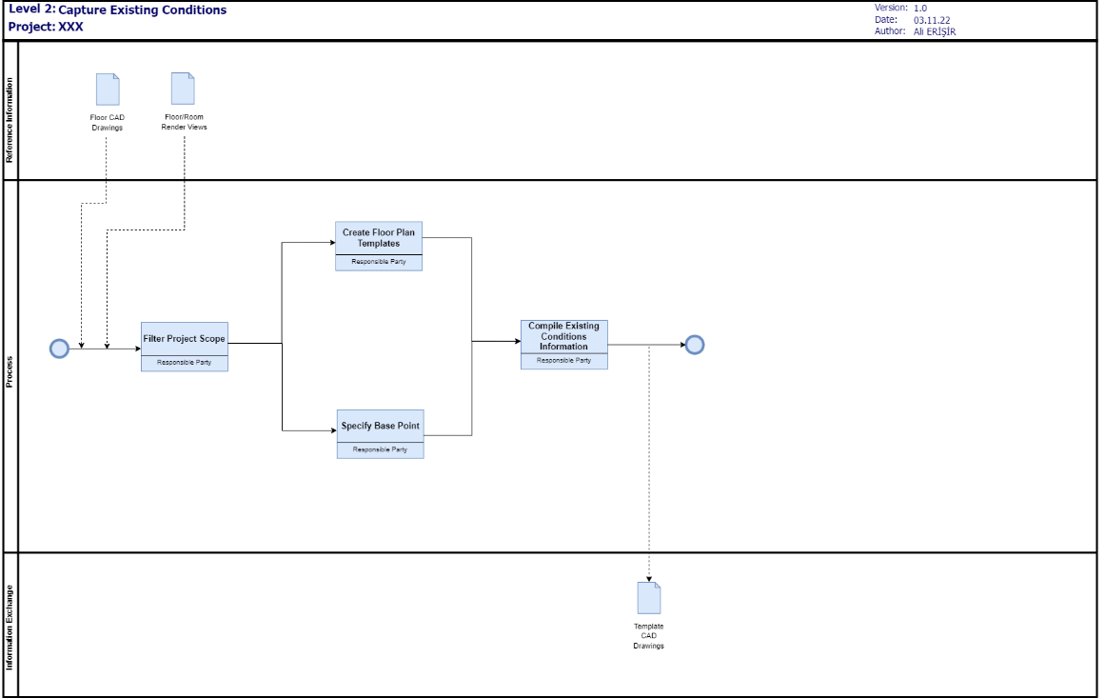

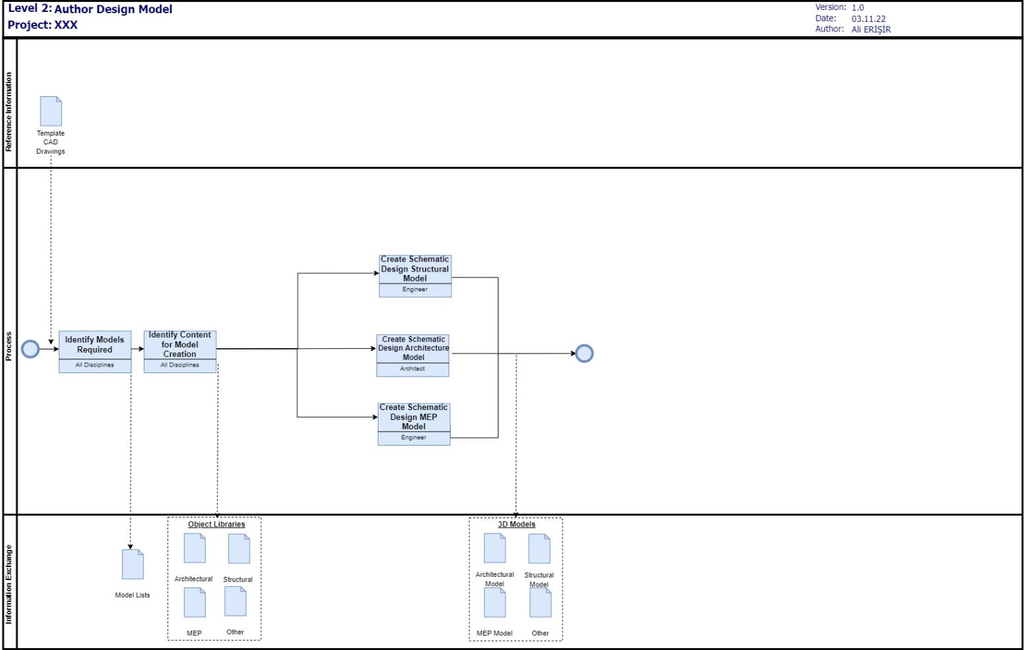 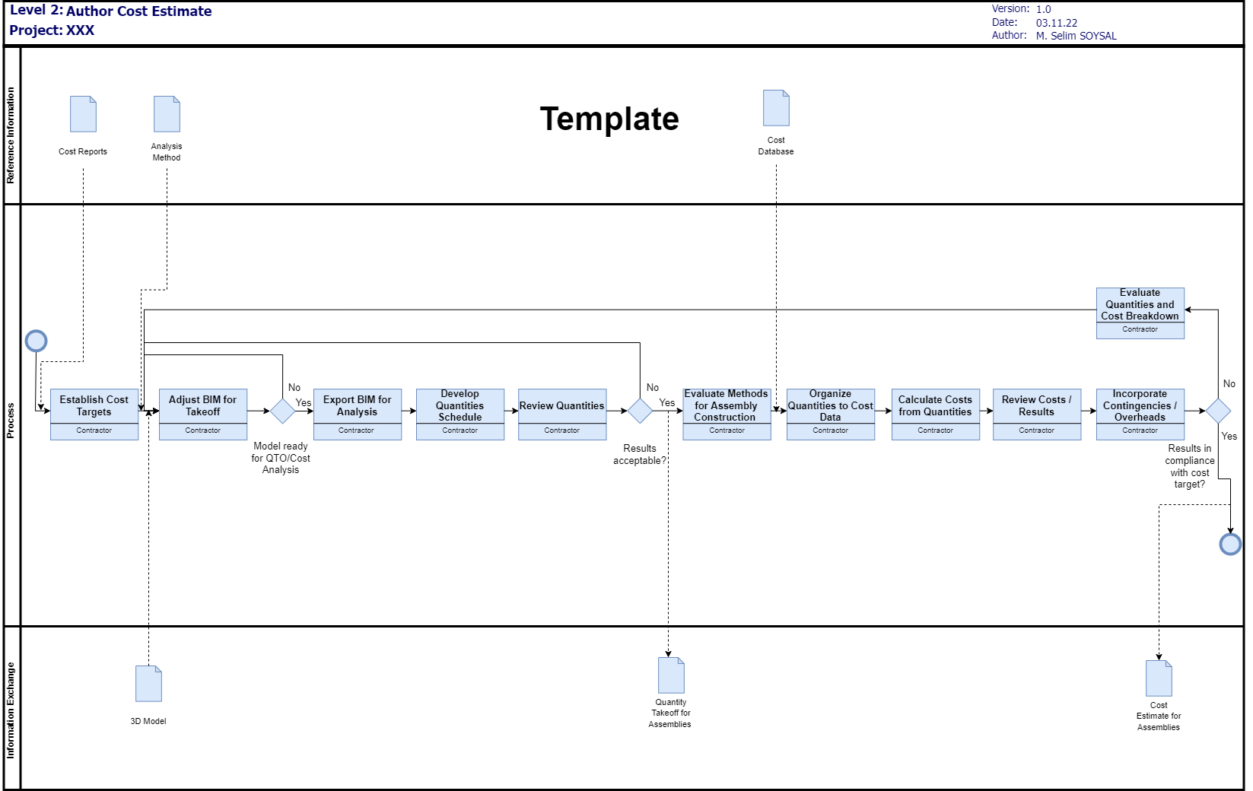 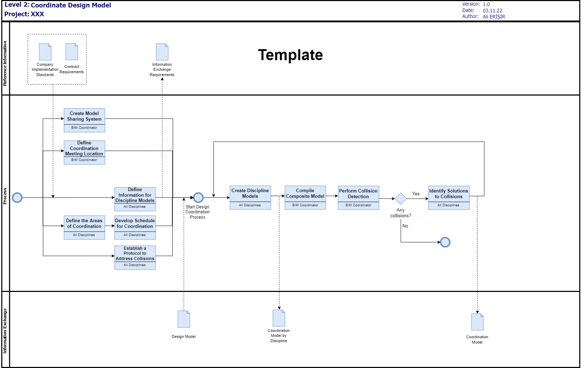 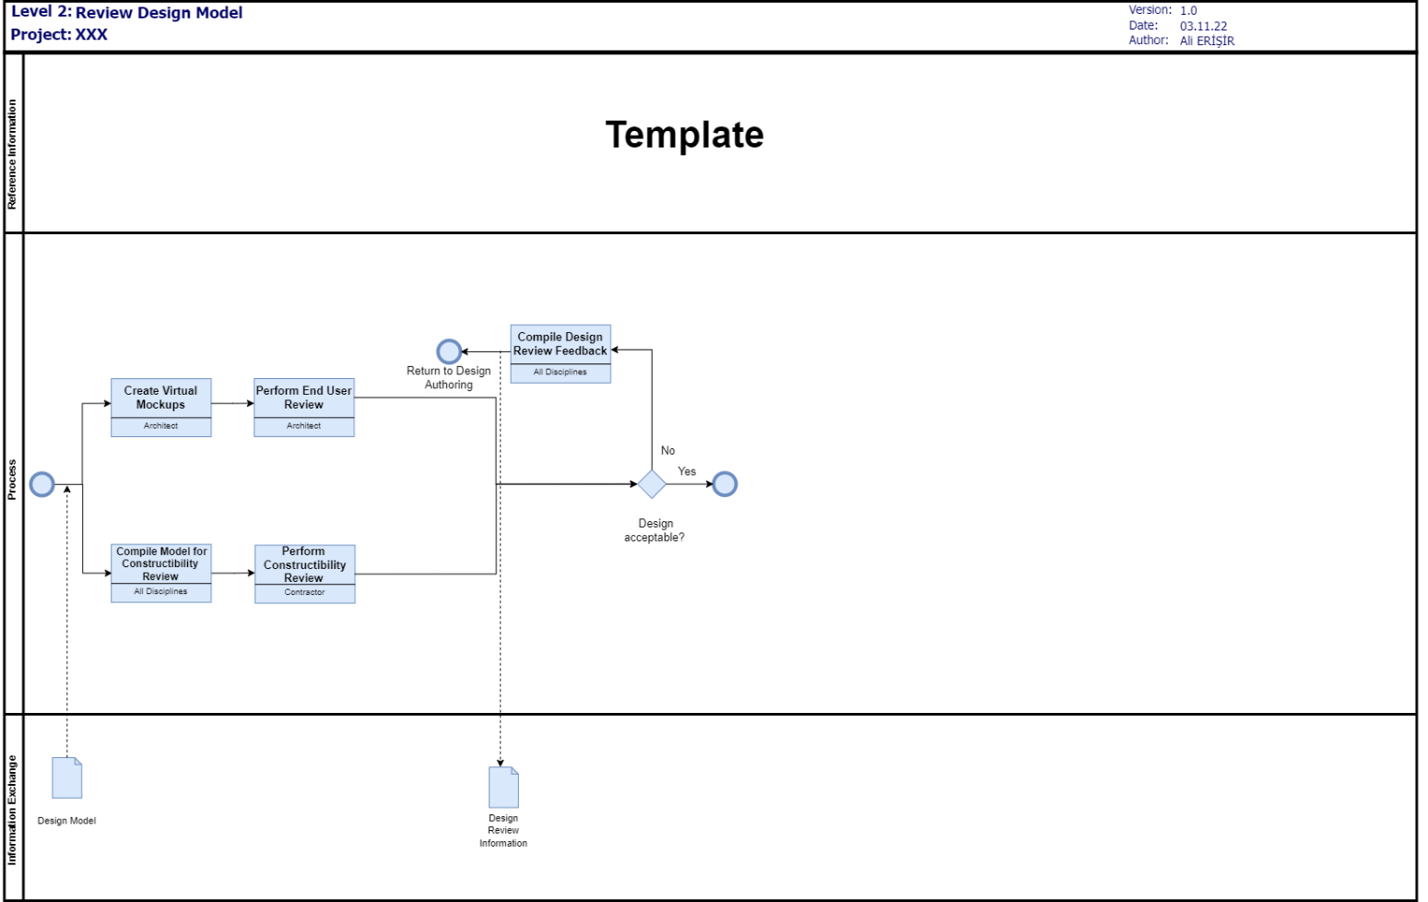

# **SECTION G: BIM INFORMATION EXCHANGES**

1. **LIST OF INFORMATION EXCHANGE WORKSHEET(S): ATTACHMENT 4**
2. **MODEL DEFINITION WORKSHEET: ATTACHMENT 5**

# **SECTION H: BIM AND FACILITY DATA REQUIREMENTS**

# **SECTION I: COLLABORATION PROCEDURES**

1. **COLLABORATION STRATEGY:**
2. **MEETING PROCEDURES:**
3. **MODEL DELIVERY SCHEDULE OF INFORMATION EXCHANGE FOR SUBMISSION AND APPROVAL:**
4. **INTERACTIVE WORKSPACE:**
5. **ELECTRONIC COMMUNICATION PROCEDURES:**

# **SECTION J: QUALITY CONTROL**

1. **OVERALL STRATEGY FOR QUALITY CONTROL:**
2. **QUALITY CONTROL CHECKS:**
3. **MODEL ACCURACY AND TOLERANCES:**

# **SECTION K: TECHNOLOGICAL INFRASTRUCTURE NEEDS**

1. **SOFTWARE:**
2. **COMPUTERS / HARDWARE:**
3. **MODELING CONTENT AND REFERENCE INFORMATION**

# **SECTION L: MODEL STRUCTURE**

1. **FILE NAMING STRUCTURE:**
2. **MODEL STRUCTURE:**
3. **MEASUREMENT AND COORDINATE SYSTEMS:**
4. **BIM AND CAD STANDARDS:**

# **SECTION M: PROJECT DELIVERABLES**

# **SECTION N: DELIVERY STRATEGY / CONTRACT**

1. **DELIVERY AND CONTRACTING STRATEGY FOR THE PROJECT:**
2. **TEAM SELECTION PROCEDURE:**
3. **BIM CONTRACTING PROCEDURE:**

# **SECTION O: ATTACHMENTS**

1. BIM USE SELECTION WORKSHEET [FROM SECTION D]
2. LEVEL 1 PROCESS OVERVIEW MAP [FROM SECTION F]
3. 3. LEVEL 2 DETAILED BIM USE PROCESS MAP(S) [FROM SECTION F]
4. 4. INFORMATION EXCHANGE REQUIREMENT WORKSHEET(S) [FROM SECTION G]
5. 5. MODEL DEFINITION WORKSHEET [FROM SECTION G]
6. 6. DEVELOPED DOCUMENTS / CONTRACTS [FROM SECTION H]